European Semester 2015/2016 country fiche on disability
Latvia | 
Report prepared by: Daina Calite-Bordane
With comparative data provided by the ANED core team

The Academic Network of European Disability experts (ANED) was established by the European Commission in 2008 to provide scientific support and advice for its disability policy Unit. In particular, the activities of the Network support the development of the European Disability Strategy 2010-2020 and practical implementation of the United Nations Convention on the Rights of Disabled People in the EU.

This country report has been prepared as input for the European Semester from a disability perspective.

Note:
The statistics provided in October 2015 are based on the EU-SILC 2013. This is the most recent microdata available to researchers for analysis from Eurostat. This report may be updated as new data becomes available.


Table of contents

1 Summary of the overall situation and challenges 2
2 Assessment of the situation of disabled people with respect to the Europe 2020 headline targets 3
2.1 Strategic targets 3
2.1.1 A note on the use of EU data 6
2.2 Employment data 7
2.2.1 Unemployment 10
2.2.2 Economic activity 14
2.3 Education data 16
2.3.1 Early school leavers 16
2.3.2 Tertiary education 20
2.4 Poverty and social exclusion data 22
3 Description of the situation and trends in relation to each target area 26
3.1 Employment 26
3.2 Education 27
3.3 Poverty and social inclusion 31
4 Assessment of policies in place to meet the relevant headline targets 34
4.1 Employment 34
4.2 Education 35
4.3 Poverty and social inclusion 35
4.4 Synergies between developments in the different areas 37
5 Review of the European Semester from a disability perspective 38
5.1 Progress on disability-specific Country Specific Recommendations (CSRs) 38
5.2 Progress on other CSRs from a disability perspective 38
5.3 Assessment of disability issues in the Country Report (CR) 39
6 Assessment of the structural funds ESIF 2014-2020 or other relevant funds in relation to disability challenges 40
7 Recommendations 43

Summary of the overall situation and challenges

As stated in EU2020 strategy, persons with disability are included in national level policy planning papers although concrete measures regarding persons with disabilities are not provided. Disabled people are defined as one of the social exclusion risk groups. Concerning measures included in the National Reform Programme, all issues to be developed between 2014-2020 and the Partnership Agreement are in compliance with the promotion of and access to employment, education and social inclusion for people with disabilities.

In recent years the number of disabled persons has increased. Also the number of persons assessed as disabled for the first time and who have a severe disability has increased. Also there has been an increase in the proportion of registered unemployed persons with disabilities and the proportion of disabled people among those considered in need. However, progress is noted regarding working people with disabilities. In general there has been progress regarding implementation of principles for the inclusion of people with disabilities in society (employment, education, social inclusion), though in several fields there proactive action is needed - in access to health care services and vocational education.

Only two of four country specific recommendations have implications for disability. One recommendation urges improvements to vocational education and training and the other recommendation suggests taking concrete steps to reform social assistance, ensuring the adequacy of benefits, and taking measures to increase employability, as well as action to improve the accessibility, cost-effectiveness and quality of the healthcare system.

It is not possible to assess whether relevant changes have taken place as during 2014-2015 there were mainly strategic policy planning papers developed to attract financing from the EU structural funds. It should be noted that in the Partnership Agreement there is an indication of measures planned, under activities to take into account regarding recommendations by the European Commission set in 2012 and 2013.

Also it needs to be mentioned that ESF resources are being used to implement several state basic functions and not focused on new and innovative measures.

At the legislative level there are defined attainable goals and tasks, though it is not possible to forecast the actual implementation of these goals and tasks as the situation may change substantially due to a political inability to decide on the state budget priorities at national level, as well as the geopolitical situation.

Assessment of the situation of disabled people with respect to the Europe 2020 headline targets

Strategic targets

Table 1: Europe 2020 and agreed national targets for the general population
 | Europe 2020 targets | National targets
Employment | 75% of the 20-64 year-olds to be employed | 73%
Education | Reducing the rates of early school leaving below 10% | 13.4%
Education | At least 40% of 30-34–year-olds completing third level education | 34-36%
Fighting poverty and social exclusion | At least 20 million fewer people in or at risk of poverty and social exclusion | Reduce by 121,000 the number of people living at  risk of poverty or social exclusion (compared to 2008) (at risk of poverty after social transfers and/or living in households with very low work intensity)

Relevant disability targets from national strategies or sources:

As mentioned in the previous EU2020 ANED report, the publication Guidelines on the Implementation of the UN Convention on the Rights of Persons with Disabilities 2014-2020 sets out an action 2. Labour and Employment. The target of this action is to take measures for the inclusion of disabled persons into the labour market by provision of appropriate support, taking into account the type of functional disorder.

Performance indicator | 2011 | 2017 | 2020
Number of employed in subsidised working places | 497 (2012) | 600 | Increase (number of employed persons with severe disability)*
Number of employed persons with mental disorders | 0 | 40 | Increase
The proportion of employed persons with disabilities (%) | 20.7 | 30 | Increase
Number of persons involved in active labour market measures | 13,051 | 17,000 | Increase
* Note: Regarding the planned results in 2020, it is only stated that numbers or proportions will increase.
The same Guidelines also set out Action 1. Education. The aim of this action is to ensure good qualitty and competitive basic and secondary education of disabled children. The target is an increase in the number of disabled children in mainstream schools from 4% in 2011 to 10% in 2017. Regarding outcomes, it is only stated that there should be an increase in the percentages.

In this policy paper there is a lack of aims targeted on the inclusion of people with disabilities in tertiary education.

In 2015 the Government approved the Inclusive Employment Guidelines for 2015-2020, which aimed at better promoting the inclusive development of the labour market, int.al. reducing the social consequences of unemployment. This is to be done by supporting unemployed people to return to the labour market and by helping socially excluded people (including people with disabilities) to stay in the labour market as long as possible, as well as by improving the quality of jobs. Implementation of measures and tasks included in the Guidelines are planned to be met from state budget resources and by attracting funding from the European Social Fund under the operational programme “Growth and Employment”. The aim of the guidelines with respect to people with disabilities is to promote their integration into the labour market at the same time facilitating the individual`s economic independence and social inclusion. In relation to the UN Convention it is planned that the model for supporting people with disabilities in various ways will be elaborated.

Separate attainable targets regarding employment of people with disabilities are not set. Indicators included in the Guidelines are in compliance with the national targets:

Result | Indicators | Base value | 2017. | 2020.
Increased employment level in the country’ | Employment level (age group 20–64, %) | 69.7% (2013) | 70.5% | 73%
Increased employment level in the age group 55-64 years | Percentage of employed among population (age group 55–64, %) | 54.8%  (2013) | Increase | Increase
Reduced percentage of unemployed | Percentage of unemployed among economically active population | 5.8%  (2013) | 4.5% | 2.5%
Reduced share of long-term unemployed | Share of long-term unemployed among all unemployed | 48.6  (2013) | 30% | 15%
Reduced at-risk-of poverty for employed | At-risk-of poverty rate for employed in the age group 18 to 64 | 9.6 (2010) | 6.5 | 5

The implementation plan, from 2015-2017, of the Guidelines on the Implementation of the UN Convention on the Rights of Persons with Disabilities 2014-2020 prepared by the Ministry of Welfare (further – MoW) is currently at the coordination stage with the Government. The Implementation Plan includes measures to promote people with disabilities’ integration in the labour market and their acquisition, development and improvement of work skills. The aim is to promote overall employment development and make progress on the targets on reducing unemployment.

By 2017, in the fields of employment, education and social inclusion, it is planned that there will be a 10% increase in the number of persons with disabilities in comprehensive schools, that 600 subsidised work places for people with disabilities will be developed, that the proportion of employed people with disabilities will increase by 30%, and that 17,000 persons with disabilities will be involved in active labour market policy measures. Further, it is planned that there will be a 15% reduction of the at risk of poverty rate for people with disabilities, that new services will be developed and that existing services will be improved, int.al. by increasing the number of persons with disabilities who receive assistant services. It is planned that the assessment system for determining disability will be improved.

A note on the use of EU data

Unless specified, the summary statistics presented in this report are drawn from 2013 EU-SILC micro data. The EU-SILC sample includes people living in private households and does not include people living in institutions. The proxy used to identify people with disabilities (impairments) is whether ‘for at least the past 6 months’ the respondent reports that they have been ‘limited because of a health problem in activities people usually do’. Responses to this question vary between countries and national data sources are added for comparison, where available.

Table 2: Self-reported ‘activity limitations’ as a proxy for impairment/disability (EU-SILC 2013)
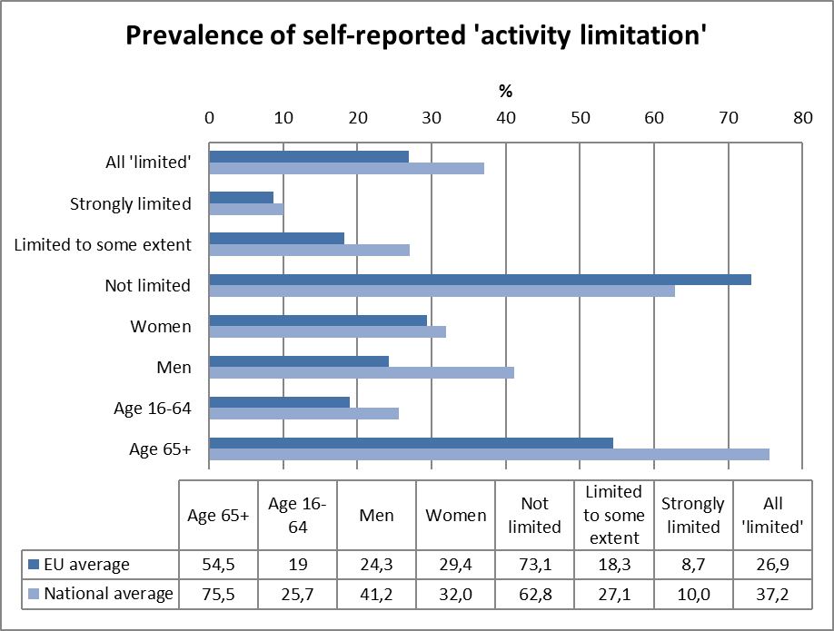
Source: EUSILC UDB 2013 – version 2 of August 2015
It is relevant to observe that Latvian estimates of impairment prevalence are above the EU average, which may affect the estimation of equality gaps.
In subsequent tables, these data are used as a proxy to estimate ‘disability’ equality in the main target areas for EU2020 – employment, education and poverty risk. The tables are presented by disaggregating the estimated proportion of people who report and do not report limitations for each indicator (e.g. among those who are employed, unemployed, at risk of poverty, etc.).

Employment data

Table 3: Most recent employment data, aged 20-64
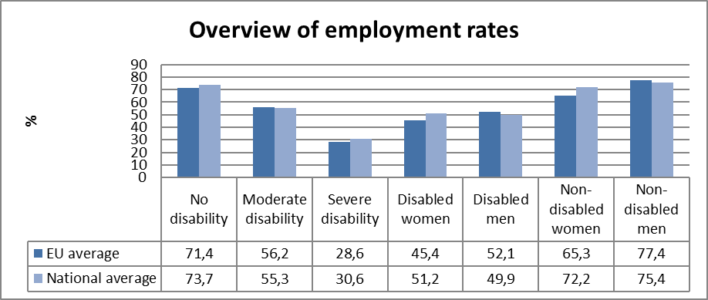
Source: EUSILC UDB 2013 – version 2 of August 2015

Table 4: Employment rate data, by age group
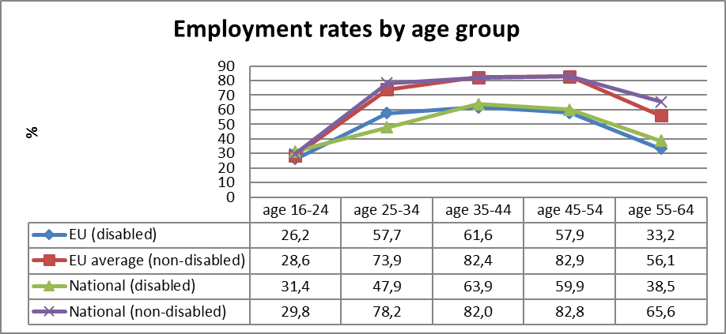
Source: EUSILC UDB 2013 – version 2 of August 2015
Table 5: Trends in employment by gender and disability (aged 20-64)
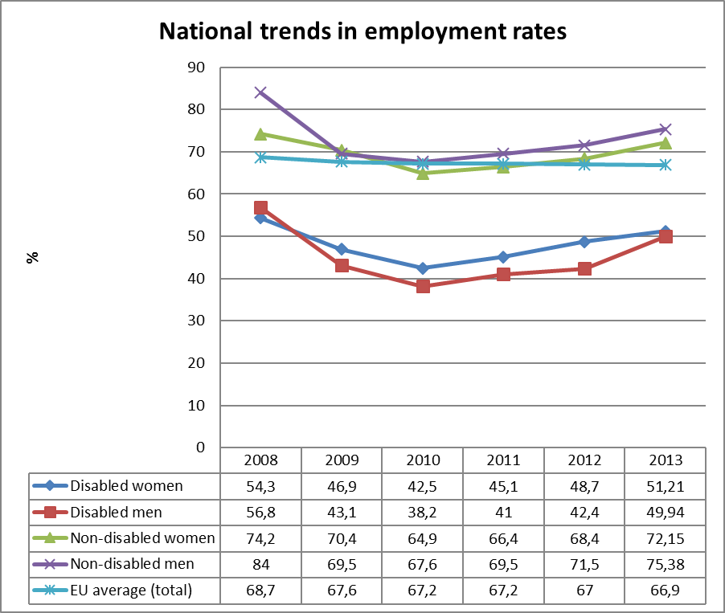
Source: EUSILC UDB 2013 – version 2 of August 2015 (and preceding UDBs)

The table above shows a comparison of national employment trends for disabled and non-disabled women and men, and compares this with the EU2020 headline indicator for the EU as a whole.

Alternative data on disability and employment provided by the national expert:
According to information in the Central Statistical Bureau (further – CSB) database, the general population has decreased in recent years by 12%, while the number of people with disabilities has increased. In the Table below, data are given from 2010.

Table: Number of Population and Disabled persons
 | 2010 | 2011 | 2012 | 2013 | 2014 | 2015
The number of people (at the beginning of the year), thousands * | 2 120.5 | 2 074.6 | 2 044.8 | 2 023.8 | 2 001.5 | 1 986.1
Disabled persons together** | 147,431 | 153,333 | 158,045 | 162,788 | 168,496 | -
Adult persons | 139,947 | 145,811 | 150,493 | 155,109 | 160,572 | -
I group | 15,670 | 17,304 | 18,720 | 20,472 | 22,407 | -
II group | 74,598 | 75,350 | 76,381 | 77,597 | 78,930 | -
III group | 49,679 | 53,157 | 55,392 | 57,040 | 59,235 | -
Disabled children | 7,484 | 7,522 | 7,552 | 7,679 | 7,924 | -
*Source: the Central Statistical Bureau
**Source: the State Social Insurance Agency, data on December

The number of persons assessed as having a disability for the first time has increased in the last few years. The majority of them are not working (see the next Table - New Cases of Disability among Population). As well as this, the level of disability determined has become more severe. In 2014, compared with 2013, the proportion of Disability I Group for people aged 18 + increased substantially: by 3.9% for persons with disability for whom a Disability Group was determined for the first time (from 4705 people in 2013 to 4887 people in 2014) but for whom disability was confirmed, the proportion increased by 8.2% (from 5237 people in 2013 to 5666 people in 2014).

Table: New Cases of Disability among the Population
Year | Total number | Working people | Non-working people
2010 | 15,894 | 5,311 | 10,583
2011 | 14,589 | 4,781 | 9,808
2012 | 15,017 | 4,813 | 10,204
2013 | 16,570 | 5,366 | 11,204
2014 | 16,188 | 5,308 | 10,880
Source: the Central Statistical Bureau
In the Initial assessment paper it is stated that the employment rate for persons in the Disability III group is more than 70%, for persons in the Disability II group 38% and only 4% for persons in the Disability group I.

In June, 2014 the number of employed disabled persons was as follows:

Table: Number of employed disabled persons
Disability group | Number of employed disabled persons |  |  | Number of disabled persons from 18 years of age | Proportion (%) of employed persons from number of disabled persons of the same group | Proportion (%) of employed persons from employed  disabled persons
Disability group | Total | Women | Men | Number of disabled persons from 18 years of age
I group | 1,459 | 662 | 797 | 22,070 | 6.61 | 2.73
II group | 14,192 | 7,106 | 7,086 | 78,283 | 18.13 | 26.55
III group | 37,798 | 11,929 | 25,869 | 59,577 | 63.44 | 70.72
Total | 53,449 | 19,697 | 33,752 | 159,930 | 33.42 | 100
Source: Data from the State Social Insurance Agency
* Data from the State Medical Commission for the Assessment of Health Condition and Working Ability

Unemployment

National administrative rules and definitions of ‘unemployment’ vary, and these may affect the way in which disabled people are categorised in different countries. The following tables compare national data with the EU2020 headline indicator for the EU.

Table 6: Most recent unemployment data, aged 20-64
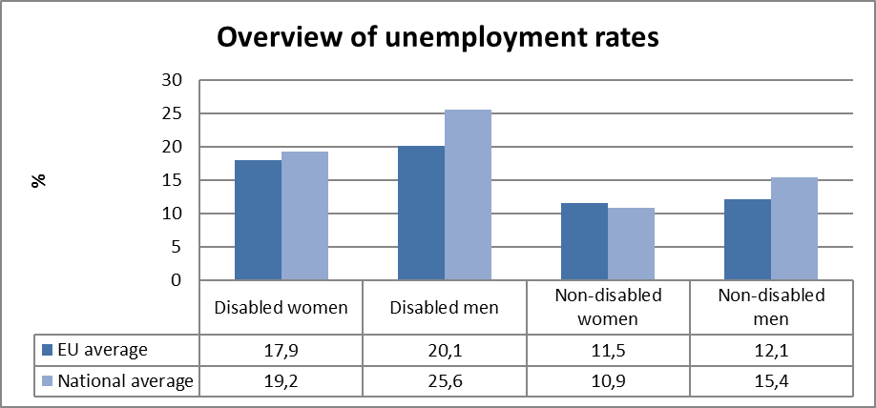
Source: EUSILC UDB 2013 – version 2 of August 2015

Table 7: Unemployment rate data, by age group
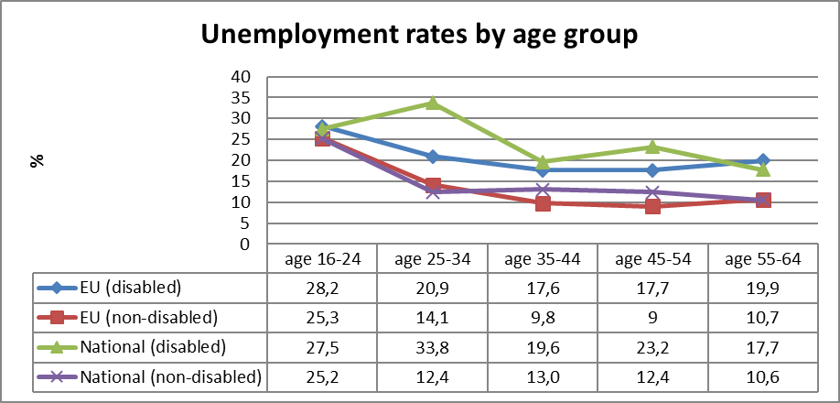
Source: EUSILC UDB 2013 – version 2 of August 2015

Table 8: Trends in unemployment by gender and disability (aged 20-64)
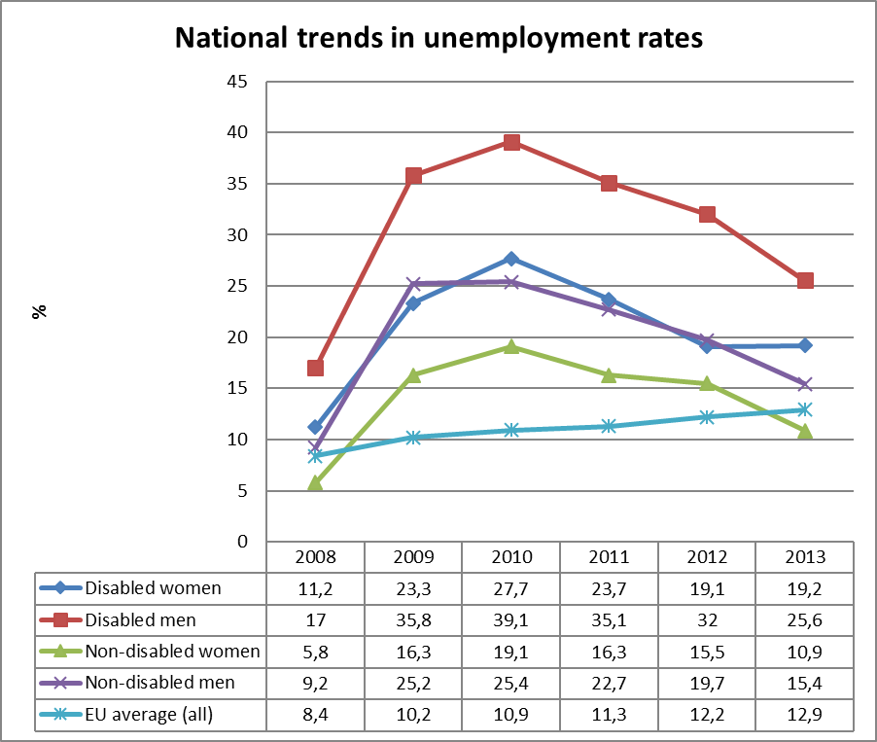
Source: EUSILC UDB 2013 – version 2 of August 2015 (and preceding UDBs)
Fluctuations in the gendered trends of unemployment for people with impairments at national level should be treated with some caution.

Alternative data on disability and unemployment from national sources:

According to information from the State Employment Agency (further – SEA) the registered unemployment rate in September 2015 was 8.3%. The registered unemployment rate in the country in recent years is as follows:

Table: Registered Unemployment Rate
Year | 2008 | 2009 | 2010 | 2011 | 2012 | 2013 | 2014 | 2015  September
Level, % | 7.0 | 16.0 | 14.3 | 11.5 | 10.5 | 9.5 | 8.6 | 8.3

Another situation can be observed regarding the registered unemployment rate for disabled persons. In recent years there have been minor changes in the number of registered unemployed disabled persons. The registered unemployment rate of disabled persons in the country was as follows:

Table: Registered Unemployment Rate of Disabled Persons
Year | 2008 | 2009 | 2010 | 2011 | 2012 | 2013 | 2014 | 2015  August
Number of registered unemployed disabled persons | 4,458 | 7,287 | 9,345 | 9,939 | 9,799 | 9,254 | 8,355 | 8,275
Proportion from all registered unemployed persons, % | 5.6 | 4.1 | 5.8 | 7.6 | 9.4 | 9.9 | 10.2 | 10,4

A trend is that the proportion of registered disabled unemployed persons has increased from 9.4% in 2012 to 9.9% in 2013 and to 10.6% in July 2014. Annual changes are small. At the end of July 2015 more than half (53.7%) of registered unemployed people with disabilities were long-term unemployed. Similarly, more than half (57.4%) of registered unemployed people with disabilities were aged 50+, while of young unemployed disabled people (aged 15-24), 3.6% were registered as unemployed.

In Guidelines for the implementation of the UN Convention on the Rights of Persons with Disabilities 2014-2020, it is indicated that at the end of 2012 there were 9,799 registered unemployed persons with disabilities. Of these, 5,127 or 52.3% were women and 4,675 or 47.7% - men. 36.3% were disabled persons in the age group 45-54 years, 24.9% in the age group 55-59 years. It means that 2/3 of unemployed disabled persons were older than 45 years. More than half or 57% registered unemployed disabled persons were long-term unemployed (they had been registered more than one year).

Economic activity

Table 9: Most recent economic activty data, aged 20-64
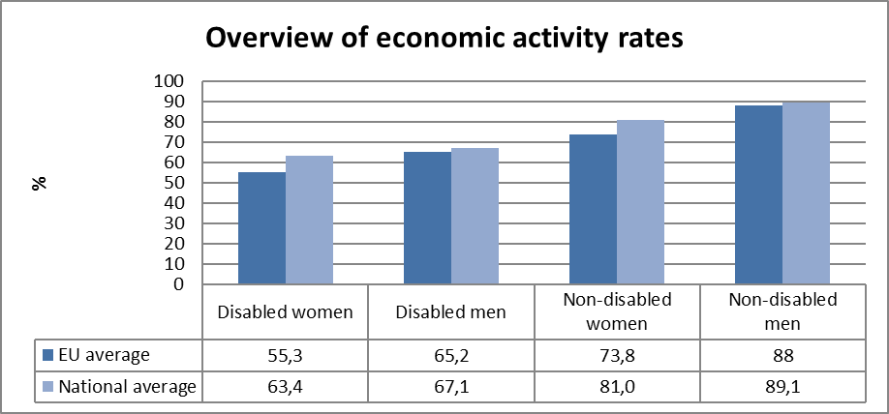
Source: EUSILC UDB 2013 – version 2 of August 2015

Table 10: Activity rate data, by age group
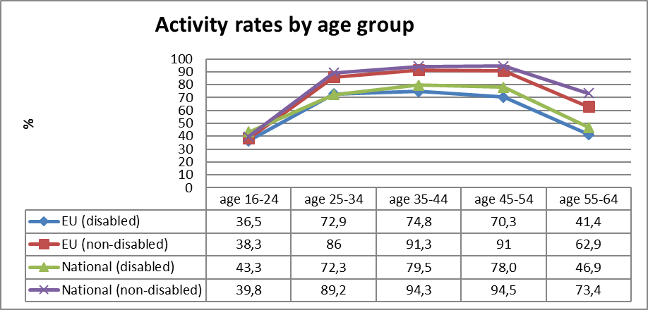
Source: EUSILC UDB 2013 – version 2 of August 2015

Table 11: Trends in activity rates by gender and disability (aged 20-64)
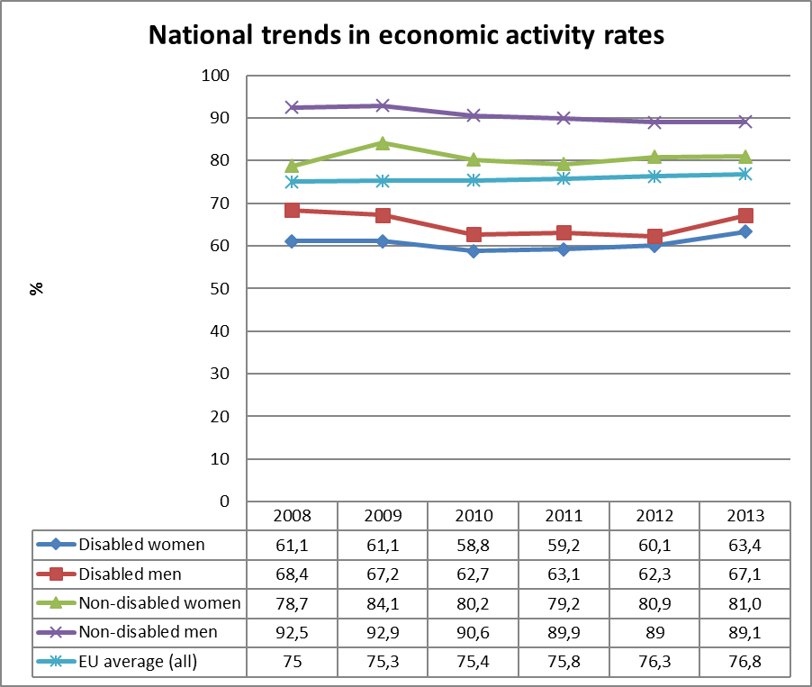
Source: EUSILC UDB 2013 – version 2 of August 2015 (and preceding UDBs)

Alternative data on disability and economic activity provided by the national expert:

There is no specific data from national sources on disability and economic activity. The overall situation on the activity rate, employment rate and unemployment rate is indicated in the following table.

Table: Activity Rate, Employment Rate and Unemployment Rate (%) of Age group 15- 64

Indicator | Activity rate in the age group 15-64 | Year | Total | Males | Females
Indicator | Activity rate in the age group 15-64 | 2010 | 73.0 | 75.3 | 70.8
Indicator | Activity rate in the age group 15-64 | 2011 | 72.8 | 75.8 | 70.1
Indicator | Activity rate in the age group 15-64 | 2012 | 74.4 | 77.1 | 72.0
Indicator | Activity rate in the age group 15-64 | 2013 | 74.0 | 76.6 | 71.6
Indicator | Activity rate in the age group 15-64 | 2014 | 74.6 | 77.8 | 71.6
Indicator | Employment rate in the the age group 15-64 | Year | Total | Males | Females
Indicator | Employment rate in the the age group 15-64 | 2010 | 58.5 | 57.9 | 59.0
Indicator | Employment rate in the the age group 15-64 | 2011 | 60.8 | 61.5 | 60.2
Indicator | Employment rate in the the age group 15-64 | 2012 | 63.0 | 64.4 | 61.6
Indicator | Employment rate in the the age group 15-64 | 2013 | 65.0 | 66.8 | 63.4
Indicator | Employment rate in the the age group 15-64 | 2014 | 66.3 | 68.4 | 64.3
Indicator | Unemployment rate in the the age group 15-64 | Year | Total | Males | Females
Indicator | Unemployment rate in the the age group 15-64 | 2010 | 19.8 | 23.0 | 16.6
Indicator | Unemployment rate in the the age group 15-64 | 2011 | 16.5 | 18.9 | 14.1
Indicator | Unemployment rate in the the age group 15-64 | 2012 | 15.3 | 16.5 | 14.2
Indicator | Unemployment rate in the the age group 15-64 | 2013 | 12.1 | 12.8 | 11.4
Indicator | Unemployment rate in the the age group 15-64 | 2014 | 11.1 | 12.1 | 10.1

Education data

EU statistical comparisons are more limited concerning the education of young disabled women and men in the EU2020 target age groups. Data is available from EU-SILC (annually) as well as the Eurostat Labour Force Survey ad-hoc disability module (for 2011), but with low reliability for several countries on the key measures. Using a wider age range can improve reliability but estimations by gender remain indicative. EU trends are evident but administrative data may offer more reliable alternatives to identify national trends, where available.

Early school leavers

The EU-SILC sample for the target age group (aged 18-24) includes the following number of people reporting activity ‘limitation’ (as a proxy for impairment/disability).

Table 12: EU-SILC sample size in the target age group 18-24 versus 18-29
 | Age 18-24 |  | Age 18-29
 | No activity ‘limitation’ | Activity ‘limitation’ | No activity ‘limitation’ | Activity ‘limitation’
EU sample | 34,413 | 2,728 | 56,461 | 4,916
National sample | 964 | 117 | 1,477 | 174
Source: EUSILC UDB 2013 – version 2 of August 2015

Table 13: Early school leavers aged 18-24 (indicative based on above sample size)
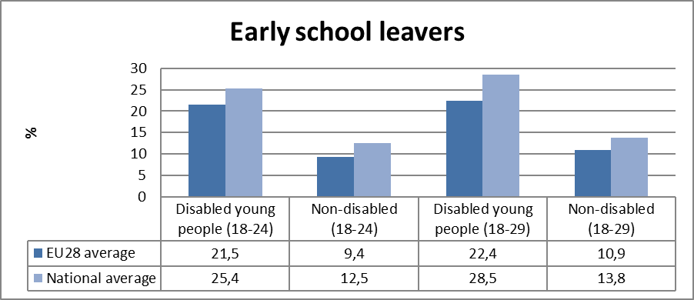
Source: EUSILC UDB 2013 – version 2 of August 2015

Alternative data on disability and early school leavers provided by the national expert:

There is no specific additional data on disabled early school leavers.

In the database of the CSB there are available data on self-reported health status. Assessments by women and men in the age group 16 - 24 indicate that there is a steady increase in the number of persons (from 1.9% in 2010 to 2.6% in 2014) who assess their health status as ‘Bad’, at the same time as the number of persons who assess their health status as ‘Very Bad’ has remained at the level of 0.3 percent to 0.2 percent.

Table: Self-Perceived Health Status by Gender and Age Groups 16-24 (%)
Year | 2010 |  | 2011 |  | 2012 |  | 2013 |  | 2014
Health status | Bad | Very Bad | Bad | Very Bad | Bad | Very Bad | Bad | Very Bad | Bad | Very Bad
Males 16-24 | 1.8 | 0.4 | 2.0 | 0.5 | 2.2 | 0.2 | 2.6 | 0.4 | 3.4 | 0.3
Females 16-24 | 2.0 | 0.2 | 1.7 | 0.2 | 1.2 | 0.4 | 2.0 | 0.3 | 1.7 | -
Total 16 - 24 | 1.9 | 0.3 | 1.9 | 0.3 | 1.7 | 0.3 | 2.3 | 0.3 | 2.6 | 0.2
Source: State Statistical Bureau Database

Other data that characterise the health status of young people are available from the State Social Insurance Agency (further – SSIA). According to information from SSIA the number of young people aged from 18 to 30 years who are recognised as disabled persons and who are receiving a disability pension has decreased. In the age group 18-24 years, the number of young disabled people receiving state social security benefits also has decreased, but there are slight increases in the number of young people in the age group 25-29 years receiving state social security benefit.

Table: Number of young disabled people (age groups 18-24 and 25-29) receiving disability pension
Number of young disabled people (age group 18-24) receiving disability pension
Year | 2010 | 2011 | 2012 | 2013 | 2014 | 2015
Women | 44 | 48 | 32 | 32 | 22 | 8
Men | 76 | 65 | 51 | 35 | 33 | 29
Total | 120 | 113 | 83 | 67 | 55 | 37
Number of young disabled people (age group 25-29) receiving disability pension
Year | 2010 | 2011 | 2012 | 2013 | 2014 | 2015
Women | 351 | 339 | 332 | 329 | 322 | 311
Men | 526 | 509 | 495 | 458 | 458 | 442
Total | 877 | 848 | 827 | 787 | 780 | 753
Source: the State Social Insurance Agency

Table: Number of young disabled people (age groups 18-24 and 25-29) receiving state social security benefit
Number of young disabled people (age group 18-24) receiving state social security benefit
Year | 2010 | 2011 | 2012 | 2013 | 2014 | 2015
Women | 2233 | 2241 | 2171 | 2072 | 1985 | 1878
Men | 3007 | 2998 | 2921 | 2772 | 2629 | 2467
Total | 5240 | 5239 | 5092 | 4844 | 4614 | 4345
Number of young disabled people (age group 25-29) receiving state social security benefit
Year | 2010 | 2011 | 2012 | 2013 | 2014 | 2015
Women | 1448 | 1480 | 1544 | 1560 | 1609 | 1614
Men | 1989 | 2097 | 2144 | 2185 | 2183 | 2196
Total | 3437 | 3577 | 3688 | 3745 | 3792 | 3810
Source: the State Social Insurance Agency

Other available data from the CSB suggest that in recent years the number of pupils who have not continued their studies after completion of primary school comprise about 5% of the total number of all who completed primary school. After completion of secondary school, 28.9% pupils did not continue their studies. That is comparatively the lowest level for recent years. More detailed information is included in the table below.

Table Basic and Secondary School Graduates: Continuing or Discontinuing Studies (%)
 | 2010 | 2011 | 2012 | 2013 | 2014
Basic school graduates, total | 100 | 100 | 100 | 100 | 100
..continue studies in secondary schools | 60.9 | 60.7 | 60.8 | 61.5 | 61.3
..continue studies in vocational schools | 33.8 | 33.9 | 33.8 | 33.4 | 33.8
..discontinue studying | 5.3 | 5.4 | 5.4 | 5.1 | 4.9
Secondary school graduates, total | 100 | 100 | 100 | 100 | 100
..continue studies in higher education institutions and colleges | 58.9 | 58.3 | 62.8 | 59.6 | 63.8
..continue studies in vocational schools. | 4.2 | 5.3 | 6.4 | 7.6 | 7.3
..discontinue studying. | 36.9 | 36.4 | 30.8 | 32.8 | 28.9
Source: the Central Statistical Bureau

However, there is no specific data on disabled pupils. It has to be noted that data about early school leavers on the webpage of the Ministry of Education and Science (further –MoES), in the section Registers and Statistics, or other databases is not specified.

Tertiary education

The EU-SILC sample for the target age group (aged 30-34) includes the following number of people reporting activity ‘limitation’ (a proxy for impairment/disability) although the number of missing observations is larger than the number of observations for activity limitation.

Table 14: EU-SILC sample size for the target age group 30-34 versus 30-39
 | Age 30-34 |  | Age 30-39
 | No activity ‘limitation’ | Activity ‘limitation’ | No activity ‘limitation’ | Activity ‘limitation’
EU sample | 23,851 | 2,866 | 50,496 | 6,732
National sample | 588 | 81 | 1,252 | 241
Source: EUSILC UDB 2013 – version 2 of August 2015

Table 15: Completion of tertiary or equivalent education (indicative based on above sample)
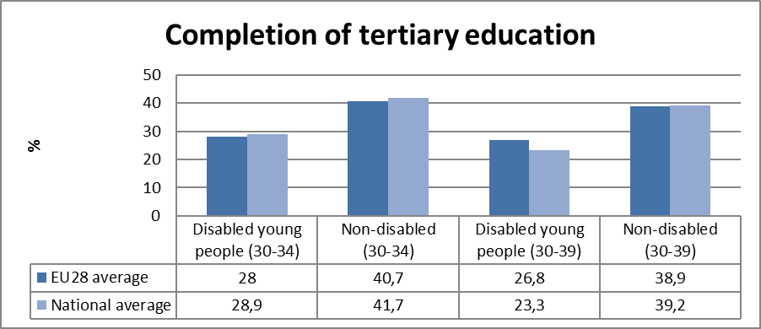
Source: EUSILC UDB 2013 – version 2 of August 2015

The survey sample is not sufficient to provide robust trend data disaggregated by gender in the narrow EU2020 target age group. In only 11 out of 28 Member States are there more than 50 observations in the sample for both women and for men in aged 30-34 who also declare impairment/limitation.

The following table is indicative at the EU level but gender trends at the national level should be treated with caution. In all Member States except Austria the achievement of tertiary education was higher for women than for men in both groups.
Table 16: Trends in tertiary education by disability (aged 30-34)
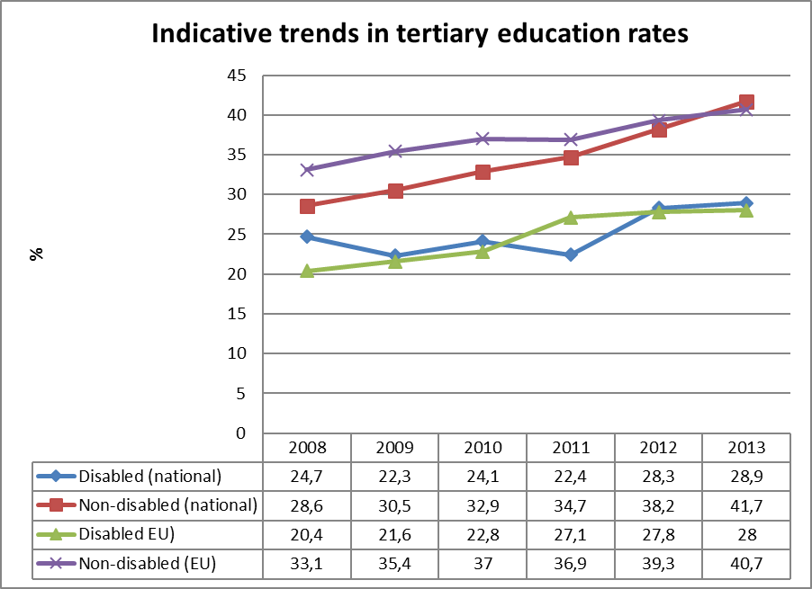
Source: EUSILC UDB 2013 – version 2 of August 2015 (and preceding UDBs)

Fluctuations in the trend for people with impairments at national level should be treated with some caution.

Alternative data on disability and tertiary education provided by the national expert:

According to information available in the database of the CBS, the number of vocational education institutions continues to reduce. At the same time the number of new pupils and graduates has increased during the last two years. However, separate data about disabled pupils and graduates are not available.

Table: Vocational Schools
 | 2009/10 | 2010/11 | 2011/12 | 2012/13 | 2013/14 | 2014/15
Number of vocational schools (at the beginning of the school year) | 85 | 83 | 65 | 65 | 66 | 63
Enrolment (at the beginning of the school year) | 36,660 | 35,767 | 34,638 | 32,086 | 31,055 | 29,855
New enrollees | 11,367 | 11,914 | 11,924 | 11,366 | 11,506 | 11,703
Graduates | 8,689 | 9,124 | 8,990 | 9,473 | 8,191 | 8,842
Source: The State Statistical Bureau Database

Every year the MoES prepares an overview about the higher education in Latvia, however, data in this overview do not include the disability dimension.

Poverty and social exclusion data

EU SILC data provides indicators of the key risks for people with disabilities. In addition to household risks of low work intensity, there are risks of low income (after social transfers), and material deprivation. These three measures are combined in the overall estimate of risk. The risks for older people do not include work intensity (Eurostat refers to the age group 0-59 for this measure). The survey does not distinguish ‘activity limitation’ (the proxy for impairment/disability) for children under the age of 16. Relevant data provided by the national expert is added where available.

Table 17: People living in household poverty and exclusion by disability and risk (aged 16-59)
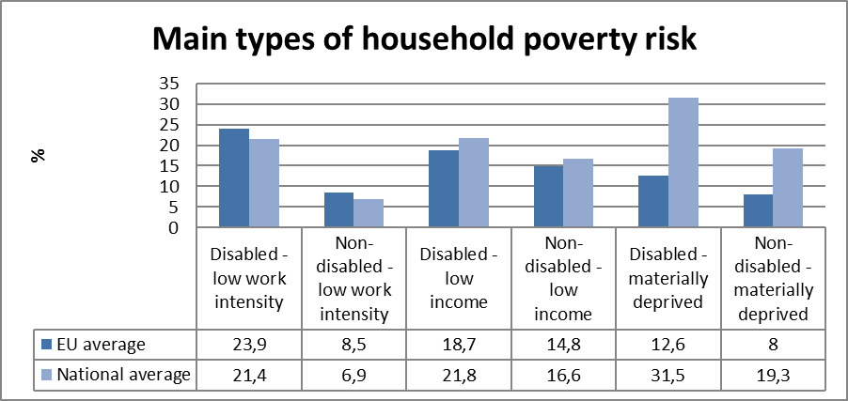
Source: EUSILC UDB 2013 – version 2 of August 2015

Table 18: People living in household poverty and exclusion by disability and gender (aged 16+)
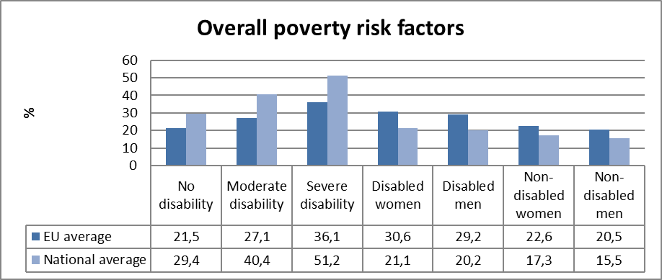
Source: EUSILC UDB 2013 – version 2 of August 2015

Table 19: Overall risk of household poverty or exclusion by disability and age (aged 16+)
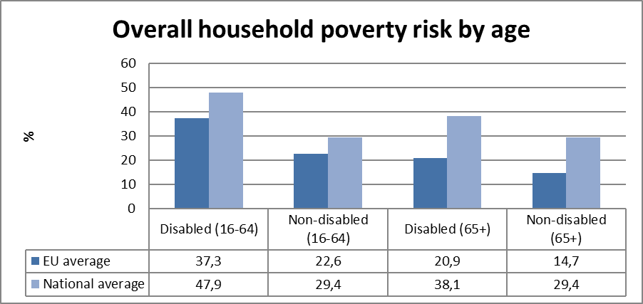
Source: EUSILC UDB 2013 – version 2 of August 2015

Table 20: Trends in household risk of poverty and exclusion by disability and age (EU-SILC 2013)
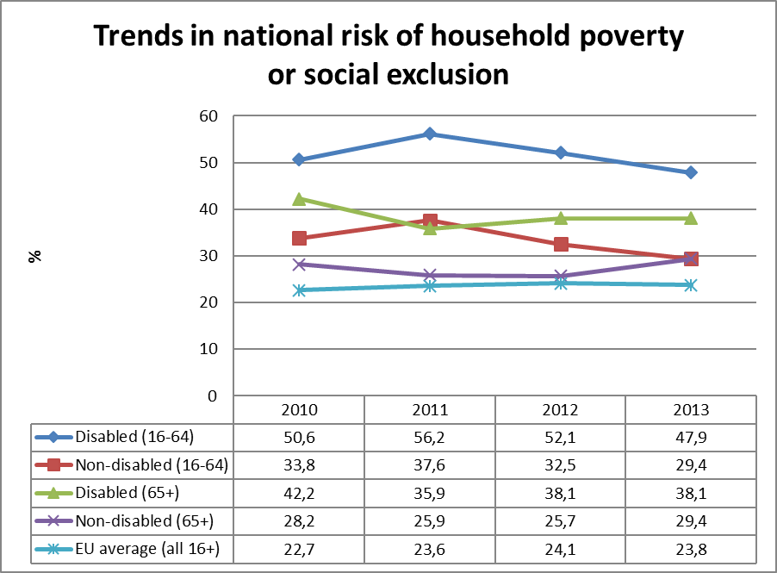
Source: EUSILC UDB 2013 – version 2 of August 2015 (and previous UDB)
Alternative data on disability and risk of poverty or social exclusion provided by the national expert:

Since 2010 the MoW has collected data on the number of people with disabilities who are in need.

Table Number of People in Need and People with Disabilities
 | Number of needy people | People with disabilities |  |  | Share from number of needy people (%)
gads | Number of needy people | Total | Adults | Children | Total | Adults | Children
2008 | 120,314 | n/d | n/d | n/d | n/d | n/d | n/d
2009 | 176,138 | n/d | n/d | n/d | n/d | n/d | n/d
2010 | 227,811 | 12,554 | 10,245 | 2,309 | 5.511 | 4.497 | 1.014
2011 | 212,876 | 13,778 | 11,316 | 2,462 | 6.472 | 5.316 | 1.157
2012 | 176,042 | 13,873 | 11,617 | 2,256 | 7.881 | 6.599 | 1.282
2013 | 134,397 | 13,910 | 11,983 | 1,927 | 10.350 | 8.916 | 1.434
2014 | 104,569 | 12,427 | 10,798 | 1,629 | 11.884 | 10.326 | 1.558
 | n/d - no data
Source: Ministry of Welfare

Even though the share of people with disabilities in need increased in 2014 compared with 2013, in absolute figures the number of people with disabilities who are in need reduced by 9.9% in one year, while the number of people in need decreased by 23.4%. The level of need has remained unchanged for 7 years (set at EUR 128.06 income per month since 2009). The reduction in the numbers of persons in need is due to various factors, mainly because after the financial crisis employment has increased and the income of people has increased from work and social transfers. Emigration has also played some role in this regard.

Description of the situation and trends in relation to each target area

Employment

In the field of employment specific statistical data on economic activity and employment level of persons with disabilities are not available. In cases of necessity the responsible institution – the MoW – receives data on the contributions of employed persons with disability through the SSIA. However, these data cannot be interpreted unequivocally since the number of people with disabilities and employed people with disabilities has increased during recent years.

According to information from the MoW, in June, 2014 there were 19,697 employed women and 33,752 employed men with disabilities. Of 159,930 persons with disability (18 years and older) only 33.4% were employed or self-employed. The employment rate of disabled persons depends on the severity of disability - the higher employment rate is for persons in the Disability III group (loss of working abilities 25-59%) – more than 70% of these persons are employed or self-employed. The employment rate for persons in the Disability II group (loss of working abilities 60-79%) is 38.0%, but at the the lowest level, it is only 4% persons with Disability I group (severe disability – loss of working abilities 80-100%).

According to SEA data it can be concluded that the number of unemployed persons with disabilities reduced from 9,939 persons in 2011 to 8,275 persons at the end of August, 2015. The proportion of registered persons with disabilities increased during the last year. The proportion of unemployed persons with disabilities was 7.6% of all unemployed persons in 2011, then in 2013 it rose to 9.9% and in 2014 it was 10.2%, and in July, 2015 - 10.4%. It has to be noted that registering with SEA is not a compulsory requirement. Therefore the situation is adequate since unemployment has improved in recent years from 14.3% in 2010 to 8.3% in September, 2015. More than half (57.4%) of all registered persons with disabilities are aged 50+ (pre-retirement age), when an interest in looking for a job decreases. Also within an SEA commissioned study it was established that persons with disabilities indicated health status as the main reason for unemployment (58.9% of all respondents), 11.1% respondents pointed out that they felt too old, while 1.9% did not work due to studying and 1.7% cited family reasons.

At the same time, an increase in registered unemployed persons with disability point to the need to differentiate support measures directly targeted at the promotion of employment of persons with disabilities. At the beginning of 2015 the Government approved the Inclusive Employment Guidelines whereby the main directions for action for the next seven years are set, indicating also the sources of funding. Within the framework of measures defined activities are set out that will promote employment of persons with disabilities though specific measures. Basically disability related issues are addressed by means of the principle of mainstreaming. The development of individualised support systems that take into account the kind of disability and the severity of functional disorder has to be addressed positively.

The SEA continues to implement different active labour market programs. 8,216 persons with disability have participated in the SEA organised active employment measures over 8 months in 2015 (one person can be involved in several measures). 2,091 persons with disability have received career consultations in 2015. In the course of 7 months in 2015, 1,494 persons with disability have entered into employment, and 664 (44.4%) of these persons got jobs after the completion of the active employment measures.

In the previous planning period (2007-2013), the employment of socially excluded people (including people with disabilities), was promoted by measures implemented by the SEA ("Measures for specific group of persons” 2008 - June, 2015). During the first 6 months after termination of the measure, 544 unemployed persons with disability got a job, including 423 with the same employer.

Key problems identified regarding youth integration in the labour market are the lack of education and experience, while for persons with disabilities it is lack of adequate support as the capabilities of these persons substantially differs according to their Disability Group and the kind of functional disorder.

Although the National Progress Report 2015 mentions that “In cooperation with the Social Integration State Agency, vocational assessment for the long-term unemployed with a disability will be implemented“ and amendments to the Social Services and Social Assistance Law have been drafted, at the time of preparing this report (November, 2015) those amendments were going through a 2nd reading in the Parliament. It is not possible to forecast when these measures will be enforced.

Education

In the education field there are available general data on the number of vocational education and higher education institutions (schools) and the number of pupils and graduates in these schools. However, data on persons with disabilities are not available. Data about early school leavers are provided on the webpage of the Ministry of Education and Science, in the section Registers and Statistics but other databases do not specify this.

According to data by the Central Statistical Bureau 0.3% of young people aged 16 to 24 have assessed their health status for the last five years as ‘very bad’ (except for 2014 when this indicator amounted to 0.2%). The proportion of young people who assessed their health status as ‘bad’ increased from 1.9% in 2010 to 2.6% in 2014.

According to SSIA data there is substantial change in the number of young people with disabilities. From 2010 to 2015 the number of disability pension recipients aged 18 to 24 years reduced by 69%, and in the age group 25 to 29 by 14%. Possibly these changes are the result of the change to the disability assessment system for children (until 2004 disability was determined by a practioner/family doctor unilaterally, but afterwards it was determined by the State Medical Commission for the Assessment of Health Condition and Working Ability) and legal regulation of receipt of the disability pension that takes into account the specific years worked and social contributions. It has to be noted that the number of social security benefit recipients for this age group has increased (by 11%) and this indicates that children with disabilities who are becoming young people basically do not work in paid jobs and continue to receive state defined benefits. To the age of 18 the benefit for a child with disability is received by their parents.

Data of the CSB suggest that in recent years the number of pupils who do not continue their studies after completion of primary school are about 5% of total number of all who complete primary school. After completion of secondary school, 28.9% pupils did not continue their studies. That is comparatively the lowest level in recent years. Separate data on pupils with disability are not available.

At the same time SEA data show that 3.6% of registered young unemployed persons aged 15 to 24 are persons with disability.

The problems of early school leaving in Latvia and the need to implement specific measures to address this problem is attested to by the study ordered by MoES (the Ministry of Education and Science) in 2014 on causes and risks of early school leaving among young people aged 13 to 18 years.

The goal of the research was to prepare a description of young persons aged 13 to 18 in the early school leaving (ESL) risk group and to identify reasons for and risks of ESL in order to introduce new and improved support activities for prevention of these risks. The main results of the research show that among ESL youth there are disproportionalty more boys in aged 16 to 18, who study in urban areas. A low level of school grades and a lack of motivation for studying are characteristic of ESL youth. The most significant ESL risks are related to insufficient involvement of parents and parental control over children’s education, as well as to the low academic skills and achievements of young persons. These are at the same time consequences and reasons for the most significant ESL risk – regular unjustified absence from studies. However, specific ESL data in this study are not given and possible risks related to disability or health status have not been analysed. In the study it is mentioned that 58% of comprehensive schools reported that a high or very high risk factor for drop-out for comprehensive schools was long-lasting and/or chronic health problems that hindered pupils form attending school regularly. This risk factor was highlighted more often by schools where are no drop-outs (65%), compared to schools that have more drop-outs - 40%.

In the field of tertiary education comparable data about disabled people are not available.

According to information available in the database of the CSB, the number of vocational education institutions has decreased in the last 5 years from 83 schools in 2011/2012 to 63 schools in the 2014/2015 study year (or by 24%). Also the number of students in this period has decreased from 35,767 to 29,885. The lowest number of new students enrolled was during the 2012/2013 study year (11,366), though in the last 2 years the number of new students has gradually increased to 11,506 in 2013/2014 and 11,703 in 2014/2015. At the same time the number of graduates has not reached the 2012/2013 level, when vocational education was acquired by 9,473 young people. This was 8,191 in the 2013/2014 study year, but 8,842 in the 2014/2015 study year. Separate data about disabled people are not available.

In addition to vocational schools that are under MoES, persons with disabilities may acquire vocational rehabilitation services in the form of vocational education at the College of Social Integration State Agency or Jūrmala Vocational Secondary School (further- JVSS).

In 2015 the number of pupils in both education institutions was the same as in 2011. In 2012 397 persons acquired a vocational education (incl., 220 in the College and 155 in the JVSS), of whom 232 (or 58%) had a severe disability (Disability I and II Group). In 2013 education was acquired by 372 persons (accordingly 179 and 175), of whom 232 (or 58%) were persons with severe disability. In 2014 vocational education was acquired by 358 persons (accordingly 200 and 158), of whom 50% and 53% were persons with severe disability. In 2015, 202 persons studied in College and 186 in JVSS.

On May 22, 2014 Parliament approved Guidelines for Education Development 2014-2020, and on June 29, 2015 the Government agreed an Implementation plan (2015-2017). By implementing activities in these papers it will be possible to ensure opportunities for persons with disability to acquire a good qualitaty education throughout the life course, to promote the competitiveness of people with disabilities in the labour market and independent living as an adult.

The Implementation plan 2015-2017 of the Guidelines on the Implementation of the UN Convention on the Rights of Persons with Disabilities 2014-2020 included measures to promote access to education and to implement the principle of inclusive education, including by performing measures focusing on awareness raising for teachers about the needs of students` with functional disorders, increasing professional competence of teachers. By 2017 it is planned to prepare a conceptual paper on the development of integrated consultancy services in higher education for persons with disability. Within the framework of this service persons with disabilities will have the possibility to receive individualised information on study programs and support services offered by high-schools. Also it is planned to extend the higher education opportunities for persons with severe disability to Disability I and II Groups.

The National Progress Report 2015 mentions that in 2014, the demand for assistant services to pupils with a disability continued to increase and assistant services in 2014 were received by 245 pupils. Public information about the number of assistant services recipients from 2012 (the first year of the introduction of assistant services) are not available.
The Implementation plan (2015-2017) of the Guidelines for Education Development 2014-2020 foresees further provision of assistant services to disabled pupils in general education schools paid for by the state budget. The planned number of recipients of the service is not specified.

Poverty and social inclusion

According to the information from the MoW the number of people in need in Latvia gradually reduced starting from 2008, though data on persons with disabilities who are in need have been available only since 2010. According to these data it may be concluded that during the last 5 years a proportion of adults with disabilities from all people in need has increased from 4.5% (2010) to 10.3% in 2015. At the same time the proportion of children with disabilities has increased during this period, from 1% to 1.5%. Even though the proportion of people with disabilities who are in need increased in 2014 compared with 2013, in absolute figures the number of people with disabilities in need has reduced by 9.9% in one year, while the overall number of people in need decreased by 23.4%.

The Latvian Government recognised the impact of income inequalities on the poverty situation, thus in the Law on the medium-term budgetary framework for 2014, 2015 and 2016, the Government set out a reduction of income inequality as one of the priorities of the budget.

At the same time actions for the reduction of poverty and social exclusion of disabled people are mainstreamed. Specific data at the national level about disabled people and poverty is not available (People at risk of poverty are calculated according to EU statistics (EU-SILC), i.e., 60% of national median equivalised disposable income (in 2014 = the 60% amounted to EUR 260 per month. People in need are counted according to national indicators. A person in need is a person whose income is less than EUR 128.06 per month.). Persons with disabilities are considered as a separate social group at risk, but in-depth studies are not carried out.

Regarding poverty, several measures to improve the quality of life for persons with disabilities have been implemented and planned, int.al. increasing the amount of benefits, promoting independent living under de-institutionalisation and promoting employment opportunities. As mentioned in the National Progress Report 2015 the Government in 2015 supported the need to increase state support to children with a disability and with celiac disease, as well as the state social benefits to people who participated in the clearing up of the Chernobyl NPP accident consequences from EUR 85.37 to EUR 100. Starting from 2014, the state social security benefit for persons with a Disability group I or Disability group II and the allowance for persons with severe disability who need special care, has been increased. Changes in institutional care services are expected from 2016, when long-term social care and social rehabilitation service institutions will be able to admit only adults with severe mental disorders. Local governments (municipalities) will be forced to develop alternative care services and support (including independent living).

In addition to measures included in National Progress Report 2015, the National Social Report (2015) includes several more measures and activities targeted to persons with disabilities: planned study about support for persons with disabilities and improvements regarding the recalculation procedure for the disability pension. However it must be mentioned that development of additional services and support measures are planned for the ESF and it is too early to judge progress.

The minimum income reform launched in 2014 also sets out improvements for persons with disabilities. On October 21, 2014 the Government approved the concept paper “Setting of the minimum income level”. The overall aim of the concept paper is to reduce poverty and income inequality based upon principles of solidarity. In the concept paper it is proposed to define a common and adequate minimum income level based on a concrete methodology for calculation, which will serve as the reference point for developing support measures in the social security system (state social benefits, social insurance, social assistance). According to this concept paper, the existing minimum income levels in Latvia are not evidence based, therefore the current minimum income amounts are very low and the poverty rates and income inequality are high. Therefore it has been proposed and adopted by the Government that the new minimum income level in Latvia will be defined as 40% of the national median equalised disposable income by using the equivalence scales: 1 for the first member of the household and 0.7 for the rest members of the household.

In 2015 the Minister for Welfare established a working group that comprised all stakeholders affected by the proposed changes. The task of the working group is to prepare a detailed analysis of each system (state social benefits, minimum pensions, social assistance), assessing the possible impacts on the income of various target groups (families with children, people with disabilities, retired people etc.) then linking the concrete social transfers with the new minimum income level, and integrating all the fields together to make a detailed calculation of the necessary financial resources. It has been determined that all the changes shall become effective as of January 1, 2017.

In May 15, 2015 a meeting with all stakeholders took place where proposals for possible changes in legal acts were presented. According to available presentations it is proposed to introduce changes in the social assistance system by anticipating higher support for people who need care (including people with disabilities), taking into account that this group is subjected to higher poverty and social exclusion risks than other social groups. Also, the presentation on state social benefits included proposals regarding several benefits targeted directly to persons with disabilities: care benefit for the child with disability, benefit to a person with disability in need of care, state social security benefit and the allowance to compensate transport expenses of persons with mobility disabilities. In compliance with the schedule, the Plan for implementing the minimum income level shall be submitted to the Cabinet of Ministers by April 1, 2016.

Assessment of policies in place to meet the relevant headline targets

Employment

To address the employment of persons with disabilities there have been prepared several policy planning papers in recent years that are related to policy planning papers at both European level (Europe 2020, Disability strategy 2010-2020) and at national level. These papers have been developed not only by the responsible institution – MoW, but also by the MoES. The most significant papers are:

- Guidelines on the Implementation of the UN Convention on the Rights of Persons with Disabilities 2014-2020 provide actions towards inclusion of disabled persons into the labour market by provision of appropriate support, taking into account the type of functional disorder. They are also concerened with quality and competitiveness of basic and secondary education of disabled children.
- Guidelines on Inclusive Employment 2015-2020 provide actions towards the integration of disabled persons into the labour market, simultaneously promoting person`s economic independence and social inclusion. In the Guidelines it is stated that in the period indicated a model for differentiating the support for persons with disabilities will be developed.
- Implementation Plan 2015-2017 of the Guidelines on the Implementation of the UN Convention on the Rights of Persons with Disabilities 2014-2020 includes measures to promote people with disabilities` integration in the labour market, acquisition, development and restoration of working skills, thereby promoting overall employment development and progress regarding the reduction of unemployment. In the Plan there are foreseen activities that will facilitate subsidised employment and strengthen social entrepreneurship principles in business. It is stated that by 2017 there should be an assessment and conclusions on possibility of introducing a quota system in Latvia.
- Guidelines for Education Development 2014-2020 and Implementation plan (2015-2017). By implementing activities in these papers it will be possible to ensure opportunities for persons with disability to acquire a good quality education throughout their life course, promote the competitiveness of people with disabilities in the labour market and independent living as adult.

It is planned that the activities included in these papers will be financed from the state budget and ESF resources. Planned expenditures for separate activities are specified in Section 6, while for introducing the legal acts there is a set procedure according to which the funding is allocated.

Education

In the field of education the Government has accepted:

- Guidelines for Education Development 2014-2020 and Implementation plan (2015-2017). One of the Guidelines for Education Development 2014-2020 action lines is "inclusion of learners with special needs into the education system and introduction of the principle of inclusive education". The aim of this action is to extend access to education and to encourage all learners who are subject to exclusion, to participate and realise their potential and opportunities, particularly because persons with special needs are less likely to find a job or to be economically active in the future.
- Implementation plan 2015-2017 of the Guidelines on the Implementation of the UN Convention on the Rights of Persons with Disabilities 2014-2020 included measures to promote access to education and implement the principle of inclusive education, including by performing measures focusing on awareness raising for teachers about the needs of students with functional disorders and increasing professional competence of teachers. By 2017 it is planned to prepare a conceptual paper on the development of integrated consultancy service in higher education for persons with disability. This service will provide an individual approach for persons with disabilities, who will have the opportunity to receive information on study programs and support services offered by high schools. Also it is planned to extend the higher education opportunities for persons with severe disability (Disability I and II Groups).
- It is planned that the activities included in these papers will be financed from the state budget and ESF resources. Planned expenditures for separate activities are specified in Section 6, while for introducing legal acts there is set a procedure according to which the funding is allocated.

Poverty and social inclusion

In addition to the activities in employment and education discussed above, Implementation plan 2015-2017 of the Guidelines on the Implementation of the UN Convention on the Rights of Persons with Disabilities 2014-2020 includes measures focused on development or improvement of state supported services for persons with disabilities. During this period it is planned that better quality services to children with disabilities and their legal representatives will be developed. Other measures include extending assistant services for Disability I and II Groups to enter higher education, improving the disability assessment system and providing vocational rehabilitation services. Several activities are targeted to support children with disabilities – to ensure social rehabilitation services for 500 children with disabilities in their homes, respite services for parents, and to make 50 places available for persons with mental disorders to receive a support person`s service. It is planned that the activities will be financed from the state budget and ESF resources. Planned expenditures for separate activities are specified in Section 6, while for introducing legal acts there is set a procedure according to which the funding is allocated.

For implementation of the Plan in the medium term, a budget of slightly over 11 million EUR annually has been allocated. It is pointed out that in 2016 and 2017 there will be a necessary additional 4 to 5 million EUR.

- Action Plan for Implementation of Deinstitutionalization 2015 - 2020 (adopted on July 15, 2015) includes activities to implement the deinstitutionalisation process by increasing the number, accessibility and quality of support measures for children with functional disorders and adults with mental disorders.
- Guidelines on Development of Professional Social Work (2014–2020) include support for social workers working, for example, with families and children and young people that have an assessed disability.
- Guidelines on Development of Social Services 2014-2020. The aim of these Guidelines is to develop an environment appropriate to person`s individual needs that would facilitate a person`s independent and dignified living. In the disability field the focus is on several innovative activities. For example, to establish a functioning assessment system, to develop a fund for exchange of assistive technologies (technical aids) for education institutions where students need them, and to develop and implement a system for certifying skills including a programme to acquire skills adapted to persons with severe disability and persons with mental disorders.

Synergies between developments in the different areas

In Latvia there is established a system that ensures a tight correlation among planning papers. The Sustainable Development Strategy of Latvia up to 2030 (Parliament announcement on 10.06.2010.) sets out the state’s long-term priorities and aims for sustainable state development. Regarding employment and social programs, the following main priorities are given: to increase human capital labour productivity, to extend the labour force base and to increase labour force participation in work, especially fostering the involvement of people with disabilities in the labour market.

National Development Plan of Latvia 2014–2020 (adopted by Parliament on 20.12.2012.) sets out medium term development priorities and there are defined aims to be achieved by 2020 regarding the increase of welfare and reduction of working poor.

In the Partnership Agreement for European Union Investment Funds 2014 – 2020 planning period (adopted by European Commission on June 20, 2014) the strategy of Latvia regarding effective and efficient use of EU funds to implement EU2020 strategy has been stated.

In the Operational Programme (OP) "Growth and employment" (adopted by European Commission on November 11, 2014) there are defined priorities, aims and attainable results in compliance with previously indicated political papers, national field strategies and other planning papers. The OP sets the general principles for implementation, monitoring and evaluation of priorities co-funded by Cohesion Policy funds.

During the development of a new policy planning paper there is a mandatory requirement to indicate a link with existing development policy planning papers, thereby ensuring that planned measures do not duplicate and are mutually corresponding.

Latvia uses a mainstreaming approach, however, disabled people are not recognised as a separate target group and disability related indicators are not analysed. Overall, planned measures in the field of employment, education and poverty reduction are adequate from the disability perspective.

Review of the European Semester from a disability perspective

Progress on disability-specific Country Specific Recommendations (CSRs)

There are no disability-specific CSRs for Latvia.

Progress on other CSRs from a disability perspective

From four CSR addressed to Latvia Recommendations 2 and 3 are relevant to disability. Recommendation 2 implies a need to improve vocational education and training, to speed up the curricula reform and to increase the offer for work-based learning. Recommendation 3 suggests the need to take concrete steps to reform social assistance, ensuring adequacy of benefits, and to take measures to increase employability, as well as to take action to improve the accessibility, cost-effectiveness and quality of the healthcare system and link hospital financing to performance mechanisms.

Basically in all fields there are developed policy planning papers that include activities to be implemented through use of the state and ESF resources. At the legislation level there are specified attainable goals. However, the situation may substantially change depending on available resources, political decisions adopted at national level, as well as the geopolitical situation. An example may be seen with the issue of refugees in Europe that may make an impact on achieving the goals previously defined.

The availability of health care services is currently an issue in society, especially in recent years (and particularly in recent months) since due to lack of funding health care services are not available (including for persons with disabilities) or there are long queues. According to sociological survey “DNB Latvian Barometr” results, a majority of inhabitants (76% of all respondents) think that health care does not correspond to their needs and only 20% consider that the Latvian health care system corresponds to their needs. 71% of respondents pointed to the cost of medical services, 69% - to the cost of pharmaceuticals and 63% - to insufficient financing. Only 1% don`t see any problems in the health care system.

A rise in prices for pharmaceuticals (48%), queues to see specialists and more expensive medical services (44%) are mentioned as negative changes.

In Latvia there has been a large increase in the number of persons with disabilities, including those persons for whom the disability has been diagnosed for the first time. As mentioned earlier, there is also a larger number of disabled persons who have a severe disability – the Disability I or II Group is increasing and the main reason is chronic, severe illnesses. Therefore it is necessary to as soon as possible bring the health care system into order by defining clear financing principles and anticipating adequate funding.

Assessment of disability issues in the Country Report (CR)

In the Country Report the problems of people with disabilities are reflected generally. Disabled persons are mentioned only three times by indicating that tapping the full labour force potential of the people with disabilities will remain important, and that there is a scope for increasing employment for older people with disabilities. There are two statistical references.

Assessment of the structural funds ESIF 2014-2020 or other relevant funds in relation to disability challenges

In the Partnership Agreement for the European Union Investment Funds 2014 -2020 persons with disability are mentioned 30 times, mainly as one of the groups at risk of social exclusion, whose needs have to be taken into account when planning support measures in employment, education, social protection, health and related areas. For example, it is indicated that by developing the primary health care for early diagnostics and treatment and by improving the accessibility of these services, the increase of sickness rate of population, disability and premature mortality will be reduced, especially by providing support to people subject to poverty and social exclusion risks (p.155).

In the Partnership Agreement it is indicated that within the horizontal principle “Equal opportunities” there will be defined specific policy goals, including to promote human resources to science and motivation for scientific activities irrespective of disability and other factors. The aim of this is to promote compliance with equal opportunities, to provide investments to improve ICT and e-services, to ensure equal opportunities for all, including persons with disabilities, to enhance receipt of services, to promote participation in society`s political, economic, social and cultural life, as well as investing in accessibility of and quality of education for people with disabilities.

The Partnership Agreement foresees that support for persons with disabilities will take several directions – development of inclusive education, support for employment and providing services at the place of residence in order to promote independent living of persons with disabilities. A special focus is ensuring improvement in EU supported physical environment, transport, ICT and other objects and services for the society (p.692).

Indicative funding according to thematic aims and funds is set out as follows:

- for stable and good quality employment and the support of labour force mobility from European Social Fund (ESF) 135 410 788 EUR, European Maritime and Fisheries Fund (EJZF) – 120189 316 EUR;
- For social inclusion by combating poverty and all kind of discrimination:
- from the European Regional Development fund (ERDF) 193 377 447 EUR, ESF – 225160 750 EUR and European Agricultural Fund for Rural Development (EAFRD) – 68 487 718 EUR;
- Investments in education, training and vocational training to acquire skills and lifelong learning from ERDF – 277 460 786 EUR, ESF -238500 493 EUR and EAFRD 16 580 422 EUR.

It is not possible to determine separate financing for activities planned for people with disabilities.

Similarly, the disability aspects have been indicated in Operational programme “Growth and Employment” adopted on November 11, 2014, that contributes to the achievement of the objectives of Strategy „EUROPE 2020”. Overall priorities are set out in the framework of this Operational program (further – OP): for a high employment rate in an inclusive society and high quality and efficiency of the education system.

In the OP there is indicated a necessity to implement measures focused on targeted support to the long-term unemployed, persons with low or inappropriate sets of skills and qualifications, older job seekers as well as other groups at risk of being subject to social exclusion.

It is planned to use EU funds to support active labour market policy measures, including support measures that will encourage the inclusion of the people with disabilities into the labour market. Funds will also be available to institutions for provision and availability of alternative social care measures as well as social rehabilitation services at home, improvement of the quality of child care services and accessibility of health services. Other issues include implementation of health promotion measures, development of a heath network and implementation of de-institutionalization. These measures are thereby contributing to implementation of the EU Council recommendations of 2013 and 2014 on active labour market measures and decrease of the youth unemployment, including implementation of Youth guarantee and use of Youth employment initiative.

In the field of vocational education, it is planned to use EU funds for modernisation of vocational education institutions, ensuring compliance of the learning environment with the development of the economic sector and improving the accessibility of vocational education, as well as development of work and practice-based learning in vocational education, strengthening the cooperation of vocational education institutions and enterprises, improving the competencies of vocational education teaching staff and improving the curriculum and study resources.

To decrease the risk of early school leaving, especially for the deprived ones, and the increase involvement of non-registered in SEA NEET children and youth into education, training or employment, CP fund support is planned for prevention, intervention and compensation measures, int.al., contributing to the implementation of the EC Recommendation of 2013 on Child Poverty.

At the end of 2014 and 2015 many regulations of the Cabinet of Ministers were adopted, which defined the procedure for implementation of measures set in OP. In the field of employment the legal framework has been developed for the following activities:

- Measures to activate long-term unemployed (Regulations No. 468 of August 11, 2015);
- Support for social entrepreneurship (Regulations No. 467 of August 11, 2015);
- active labour market policy measures to promote employment of young unemployed and implement vocational education programme under Youth Guarantee (Regulations No. 207 of April 28, 2015);
- Subsidized work places for the most vulnerable unemployed (Regulations No. 835 of December 23, 2014);
- To Increase qualification and skills for unemployed according to labour market demands (Regulations No. 836 of December 23, 2014).
- In social inclusion field:
- -Studies and monitoring on inclusive labour market and at-risk-of poverty (Regulations No. 386 of July 7, 2015).
- -Deinstitutionalization (Regulations No.313 of June, 2015).
- In the field of education: information is not available.

Recommendations

At both EU and national levels it is necessary to develop common databases where data can be compiled that ts required for the UN Convention on Disability and to assess the progress towards aims defined in policy planning papers. This applies especially regarding inclusive education and disaggregated data by disability in poverty and social exclusion field.

The Inclusive education principle must be applied also to tertiary education since the current focus of policy planning papers (UN Convention on Disability and Plan for its implementation) is on general and basic education.

There is a need for active measures regarding access to health care for people with disabilities to prevent current negative tendencies regarding high incidences of chronic illnesses.

http://ec.europa.eu/europe2020/pdf/targets_en.pdf.
Guidelines for the implementation of the UN Convention on the Rights of Persons with Disabilities 2014-2020, https://polsis.mk.gov.lv/LoadAtt/file21919.doc.
Inclusive Employment Guidelines for 2015-2020 http://www.lm.gov.lv/upload/darba_tirgus/pamatnostadnes_latvijas_vestnesis.pdf.
Implementation plan 2015-2017 of the Guidelines on the Implementation of the UN Convention on the Rights of Persons with Disabilities 2014-2020; http://tap.mk.gov.lv/lv/mk/tap/?dateFrom=2014-10-21&dateTo=2015-10-21&vss&text=&org=142968&area=0&type=0.
EUSILC UDB 2013 – version 2 of August 2015.
The SILC survey questions are contained in the Minimum European Health Module (MEHM) http://epp.eurostat.ec.europa.eu/statistics_explained/index.php/Glossary:Minimum_European_Health_Module_(MEHM).
The methodology is further explained in the annual statistical reports of ANED, available at http://www.disability-europe.net/theme/statistical-indicators.
The Central Statistical Bureau Database http://data.csb.gov.lv/pxweb/lv/Sociala/Sociala__isterm__iedz/IE0010m.px/table/tableViewLayout1/?rxid=cdcb978c-22b0-416a-aacc-aa650d3e2ce0.
Disability group I - severe disability, loss of working abilities 80-100%, disability group II – loss of working abilities 60-79%, disability group III - loss of working abilities 25-59%.
http://www.vdeavk.gov.lv/wp-content/uploads/2014/09/PARSKATS_2014_1_dala.pdf.
The Central Statistical Bureau Database http://data.csb.gov.lv/pxweb/en/Sociala/Sociala__ikgad__veseliba/VA0120.px/table/tableViewLayout2/?rxid=a79839fe-11ba-4ecd-8cc3-4035692c5fc8.
European Union planning period 2014-2020 Operational Programme “Growth and employment” 9.1.4. specific objective “Increase the integration of people at risk of discrimination in the society and labour market” 9.1.4.1. measure “Vocational rehabilitation. Initial assessment.”, February, 2015, page 14 and page 23 http://kom.esfondi.lv/Shared%20Documents/LM_SN_9141_26022015.doc.
Disability group I - severe disability, loss of working abilities 80-100%, disability group II – loss of working abilities 60-79%, disability group III - loss of working abilities 25-59%.
http://www.vdeavk.gov.lv/wp-content/uploads/2014/09/PARSKATS_2014_1_dala.pdf.
The unemployment situation in the country (September, 2015) http://www.nva.gov.lv/docs/28_56029f39785904.28165018.pdf.
The unemployment situation in the country (September, 2015) http://www.nva.gov.lv/docs/28_56029f39785904.28165018.pdf.
Guidelines for the implementation of the UN Convention on the Rights of Persons with Disabilities 2014-2020, page 13, https://polsis.mk.gov.lv/LoadAtt/file21919.doc.
The Central Statistical Bureau Database http://data.csb.gov.lv/pxweb/en/Sociala/Sociala__ikgad__nodarb/NB0020.px/sortedtable/tableViewSorted/?rxid=a79839fe-11ba-4ecd-8cc3-4035692c5fc8.
For the LFS AHM data see, Early school leavers http://appsso.eurostat.ec.europa.eu/nui/show.do?dataset=hlth_de010&lang=en and tertiary educational attainment http://appsso.eurostat.ec.europa.eu/nui/show.do?dataset=hlth_de020&lang=en.
The Central Statistical Bureau Database. http://data.csb.gov.lv/pxweb/en/Sociala/Sociala__ikgad__vesel_pasnovert/VP0040.px/table/tableViewLayout1/?rxid=cdcb978c-22b0-416a-aacc-aa650d3e2ce0.
The State Social Insurance Agency; http://www.vsaa.lv/lv/budzets-un-statistika/statistika Please note that this information was provided following a special request by the author of this report. These are not official statistics.
The Central Statistical Bureau Database http://data.csb.gov.lv/pxweb/en/Sociala/Sociala__ikgad__izgl/IZ0180.px/table/tableViewLayout1/?rxid=a79839fe-11ba-4ecd-8cc3-4035692c5fc8.
The State Statistical Bureau Database http://data.csb.gov.lv/pxweb/en/Sociala/Sociala__ikgad__izgl/IZ0220.px/table/tableViewLayout2/?rxid=a79839fe-11ba-4ecd-8cc3-4035692c5fc8.
Overview about the higher education in Latvia, http://www.izm.gov.lv/images/statistika/augst_izgl/14.pdf.
The income level for persons in need is set at EUR 128.06 per month per person. A person or family whose income is less than EUR 128.06 per month per person during last three months is recognized as a person (or family) in need (of course, if material conditions are met).
Information from the Ministry of Welfare.
European Union planning period 2014-2020 Operational Programme “Growth and employment” 9.1.4. specific objective “Increase the integration of people at risk of discrimination in the society and labour market” 9.1.4.1. measure “Vocational rehabilitation. Initial assessment.”, February, 2015, page 14, http://kom.esfondi.lv/Shared%20Documents/LM_SN_9141_26022015.doc.
The unemployment situation in the country (September, 2015) http://www.nva.gov.lv/docs/28_56029f39785904.28165018.pdf.
Inclusive Employment Guidelines for 2015-2020; http://www.lm.gov.lv/upload/darba_tirgus/pamatnostadnes_latvijas_vestnesis.pdf, p.20.
Inclusive Employment Guidelines for 2015-2020; http://www.lm.gov.lv/upload/darba_tirgus/pamatnostadnes_latvijas_vestnesis.pdf.
The unemployment situation in the country (September, 2015) http://www.nva.gov.lv/docs/28_56029f39785904.28165018.pdf.
National Reform Programme of Latvia for the Implementation of the “EUROPE 2020” Strategy Progress Report, p.20, http://ec.europa.eu/europe2020/pdf/csr2015/nrp2015_latvia_en.pdf.
The Central Statistical Bureau http://data.csb.gov.lv/pxweb/en/Sociala/Sociala__ikgad__vesel_pasnovert/VP0040.px/table/tableViewLayout1/?rxid=cdcb978c-22b0-416a-aacc-aa650d3e2ce0.
The State Social Insurance Agency; http://www.vsaa.lv/lv/budzets-un-statistika/statistika.
The Central Statistical Bureau Database http://data.csb.gov.lv/pxweb/en/Sociala/Sociala__ikgad__izgl/IZ0180.px/table/tableViewLayout1/?rxid=a79839fe-11ba-4ecd-8cc3-4035692c5fc8.
The unemployment situation in the country (September, 2015) http://www.nva.gov.lv/docs/28_56029f39785904.28165018.pdf.
Study on causes and risks of early school leaving among young people aged 13 to 18 years; http://www.izm.gov.lv/images/statistika/petijumi/41.pdf.
Ibid.
Study on causes and risks of early school leaving among young people aged 13 to 18 years; http://www.izm.gov.lv/images/statistika/petijumi/41.pdf.
The State Statistical Bureau Database http://data.csb.gov.lv/pxweb/en/Sociala/Sociala__ikgad__izgl/IZ0220.px/table/tableViewLayout2/?rxid=a79839fe-11ba-4ecd-8cc3-4035692c5fc8.
Guidelines for Education Development 2014-2020; http://likumi.lv/doc.php?id=266406.
Implementation plan (2015-2017) of Guidelines for Education Development 2014-2020; http://likumi.lv/ta/id/274936-par-izglitibas-attistibas-pamatnostadnu-2014-2020-gadam-istenosanas-planu-2015-2017-gadam.
Implementation plan 2015-2017 of the Guidelines on the Implementation of the UN Convention on the Rights of Persons with Disabilities 2014-2020; http://tap.mk.gov.lv/lv/mk/tap/?dateFrom=2014-10-21&dateTo=2015-10-21&vss&text=&org=142968&area=0&type=0.
National Reform Programme of Latvia for the Implementation of the “EUROPE 2020” Strategy Progress Report, p.64, http://ec.europa.eu/europe2020/pdf/csr2015/nrp2015_latvia_en.pdf.
Assistant services ensure assistance to pupil when moving at an education institution, including the breaks and extended-day groups, out-of-class events and when accessing venues of the events organised by the education institution, as well as support to participate in the events, support when making contact and communicating with other pupils, teachers, and other persons, and support to self-care was provided.
http://www.izm.gov.lv/lv/publikacijas-un-statistika/statistika-par-visparejo-izglitibu/2014-2015-m-g.
http://m.likumi.lv/doc.php?id=274936.
http://likumi.lv/doc.php?id=262267.
Employment situation is described in section 3.1.
National Reform Programme of Latvia for the Implementation of the “EUROPE 2020” Strategy Progress Report, p.77, http://ec.europa.eu/europe2020/pdf/csr2015/nrp2015_latvia_en.pdf.
The National Social Report (2015) http://ec.europa.eu/social/keyDocuments.jsp?pager.offset=10&langId=en&mode=advancedSubmit&policyArea=750&subCategory=758&year=0&country=0&type=0&advSearchKey=SPCNationalSocialReport.
Detailed information in section 6.
The concept paper “Setting of the minimum income level”, http://polsis.mk.gov.lv/view.do?id=5031.
Guidelines for the implementation of the UN Convention on the Rights of Persons with Disabilities 2014-2020, http://polsis.mk.gov.lv/LoadAtt/file21919.doc.
Guidelines on Inclusive Employment 2015-2020; http://www.lm.gov.lv/upload/darba_tirgus/pamatnostadnes_latvijas_vestnesis.pdf
Implementation Plan 2015-2017 of the Guidelines on the Implementation of the UN Convention on the Rights of Persons with Disabilities 2014-2020; http://tap.mk.gov.lv/lv/mk/tap/?dateFrom=2014-10-21&dateTo=2015-10-21&vss&text=&org=142968&area=0&type=0.
Guidelines for Education Development 2014-2020; http://likumi.lv/doc.php?id=266406
Implementation plan (2015-2017) of Guidelines for Education Development 2014-2020; http://likumi.lv/ta/id/274936-par-izglitibas-attistibas-pamatnostadnu-2014-2020-gadam-istenosanas-planu-2015-2017-gadam.
Guidelines for Education Development 2014-2020; http://m.likumi.lv/doc.php?id=266406.
Implementation plan (2015-2017) of Guidelines for Education Development 2014-2020; http://likumi.lv/ta/id/274936-par-izglitibas-attistibas-pamatnostadnu-2014-2020-gadam-istenosanas-planu-2015-2017-gadam.
Implementation Plan 2015-2017 of the Guidelines on the Implementation of the UN Convention on the Rights of Persons with Disabilities 2014-2020; http://tap.mk.gov.lv/lv/mk/tap/?dateFrom=2014-10-21&dateTo=2015-10-21&vss&text=&org=142968&area=0&type=0.
Implementation Plan 2015-2017 of the Guidelines on the Implementation of the UN Convention on the Rights of Persons with Disabilities 2014-2020; http://tap.mk.gov.lv/lv/mk/tap/?dateFrom=2014-10-21&dateTo=2015-10-21&vss&text=&org=142968&area=0&type=0.
Action Plan for Implementation of Deinstitutionalization 2015 – 2020; http://www.lm.gov.lv/text/3071.
Guidelines on Development of Professional Social Work (2014–2020; http://polsis.mk.gov.lv/view.do?id=4591.
Guidelines on Development of Social Services 2014-2020; http://polsis.mk.gov.lv/view.do?id=4558.
Sustainable Development Strategy of Latvia up to 2030; http://polsis.mk.gov.lv/view.do?id=3323
National Development Plan of Latvia 2014–2020; http://www.pkc.gov.lv/images/NAP2020%20dokumenti/NDP2020_English_Final.pdf.
Partnership Agreement for the European Union Investment Funds 2014 -2020 planning period http://ec.europa.eu/contracts_grants/pa/partnership-agreement-latvia-summary_lv.pdf.
Operational Programme "Growth and employment"; http://ec.europa.eu/esf/main.jsp?catId=576&langId=en.
COUNCIL RECOMMENDATION of 14 July 2015; http://ec.europa.eu/europe2020/pdf/csr2015/csr2015_council_latvia_en.pdf.
Sociological survey “DNB Latvian Barometr” http://www.tvnet.lv/zinas/viedokli/581005-aptauja_veselibas_aprupes_sistema_neatbilst_iedzivotaju_vajadzibam.
Partnership Agreement for the European Union Investment Funds 2014 -2020 planning period http://ec.europa.eu/contracts_grants/pa/partnership-agreement-latvia-summary_lv.pdf.
Operational programme “Growth and Employment”; p.14-17. http://www.esfondi.lv/upload/Planosana/FMProg_270115_OP_ENG_2.pdf.
Ministry of Welfare; http://www.lm.gov.lv/text/440.
Regulations No. 468 of August 11, 2015; http://likumi.lv/ta/id/275991.
Regulations No. 467 of August 11, 2015; http://likumi.lv/ta/id/275959-darbibas-programmas-izaugsme-un-nodarbinatiba-9-1-1-specifiska-atbalsta-merka-palielinat-nelabveligaka-situacija-esosu.
Regulations No. 207 of April 28, 2015; http://likumi.lv/ta/id/274081-darbibas-programmas-izaugsme-un-nodarbinatiba-7-2-1-specifiska-atbalsta-merka-palielinat-nodarbinatiba-izglitiba-vai.
Regulations No. 835 of December 23, 2014; http://m.likumi.lv/doc.php?id=271411.
Regulations No. 836 of December 23, 2014; http://likumi.lv/ta/id/271412-darbibas-programmas-izaugsme-un-nodarbinatiba-7-1-1-specifiska-atbalsta-merka-paaugstinat-bezdarbnieku-kvalifikaciju-un.
Regulations No. 386 of July 7, 2015; http://likumi.lv/ta/id/275336.
Regulations No.313 of June, 2015; http://likumi.lv/ta/id/274957-darbibas-programmas-izaugsme-un-nodarbinatiba-9-2-2-specifiska-atbalsta-merka-palielinat-kvalitativu-institucionalai-aprupei.

